**DIGITAL DIVIDE**

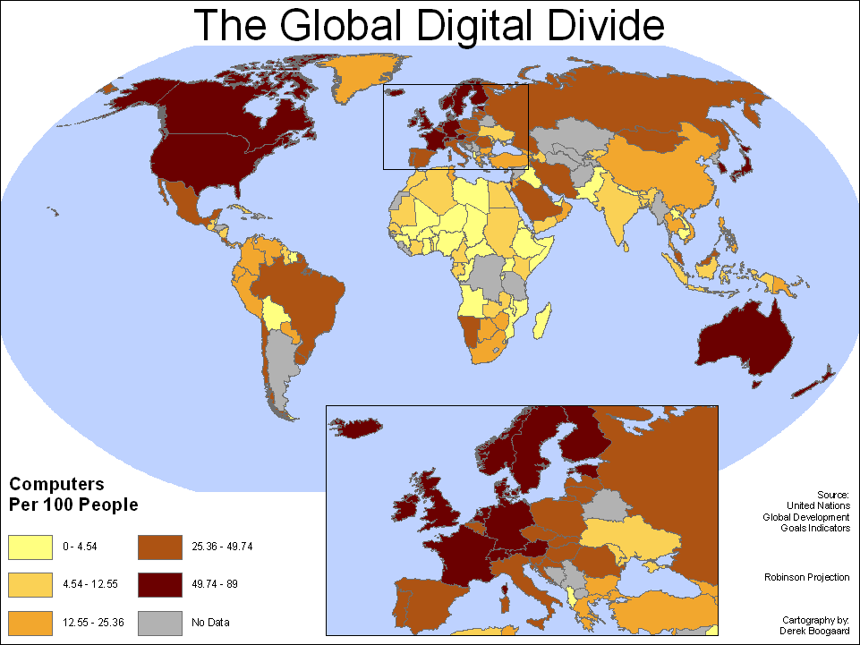Many people believe that everyone, regardless of the circumstances, should be able to benefit from the Information Age and that technology-enabled information and services should be available to all. The Digital Divide, also known as Digital Split, is a term that refers to the gap between the demographics (statistical study of populations) and regions that have different amount of information, those that have access to modern information and communication technology and those who have restricted access. This technology can include telephone services, personal computers, the internet etc.

Where does the Digital Divide Exist?

The digital divide exists between those in cities and those in rural areas; between the educated and the uneducated; between socio-economic groups and, globally, between the more and less industrially developed nations. Even among populations with some access to technology, lower-speed wireless connections, lower priced connections such as dial-up and limited access to subscription-based content.

**WORLD INTERNET USERS (in 2007)**

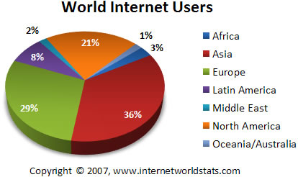

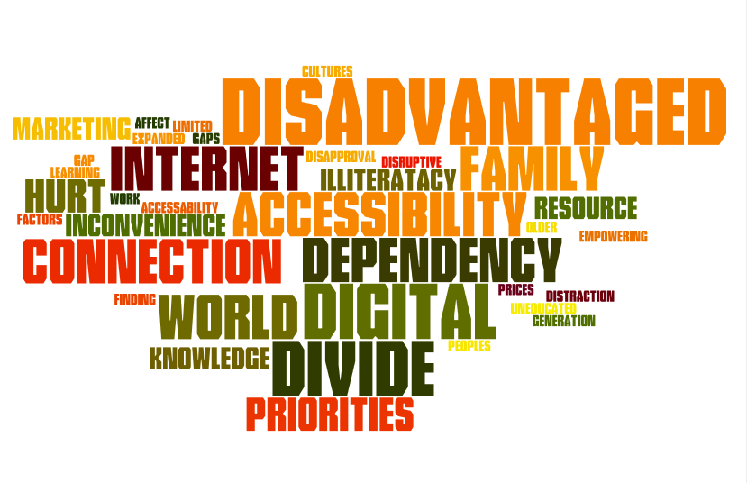

**Factors That Create Digital Divide**

1. **Economic Factors**

The digital divide is manifested in the fact that some people can’t afford to buy a computer. We should acknowledge the fact that for developing countries, computers will remain out of citizen’s reach for at least 20years or more. For businesses that remains as an extra cost in order for them to cater for all their employees. In schools the government will need to award grants to help with such costs.

1. **Geographical Factors**

Access to the world of information is also dependent on where one lives. In most places rural areas are deprived of what some people might to refer to as a “necessity”. Geographical areas have a great influence on a person’s wealth or education wealthier families are likely to have access to the internet. Some areas also lack good connectivity maybe due to obstruction from e.g. trees.

1. **Social Factors**
2. **Age-** it seems that younger people in this generation are more comfortable with the new technology and are able to benefit from it than older people.
3. **Literacy-** simple skills like reading will be very useful when using this new technology, if the literacy levels in an area are low then it is expected that there is a gap between that area and other areas.
4. **Motivation-** people may not use computers because they are not interested or may not see any good reason to use it. Others have a fear/phobia of using computers this people can be referred to as *“technophobes”* this is mainly caused due to poor ICT skills.

**Impacts of Digital Divide**

1. **Economic impacts**

* *People* with internet access are able to take opportunities, such as :

1. **Shopping:** online shopping is becoming the most common way to transact. So people are able to get the best buys from shops all around the world.

* Businesses plugging into the world boosts the amount of trade available to a businesses and also that of other countries where they are located. Opening up access to world markets boosts other local industries too such as the businesses that supply the world trader.

1. **Social impacts**

* There is a potential for social conflict in communities where some are wealthier and have computers and access to the internet while others lack these amenities.
* Social opportunities that arise from the use of ICT:
* Use of chatrooms to keep in touch with other people or make new friends, this is mostly common with the youth.
* 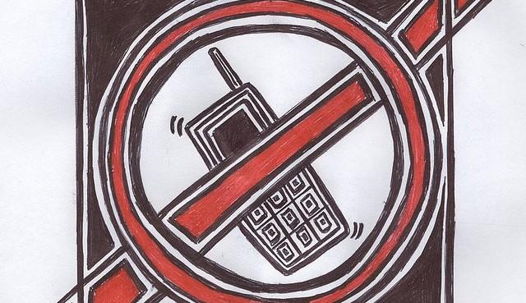You have an access to wider range of jobs opportunities by looking on the internet
* Participate in on-line social activities .e.g. playing video games.

1. **Cultural impacts**

* There patchy nature of internet connections across the world has affected and also been affected by local customs and attitudes. In particular some countries limit the access of people to the internet because they are worried that there may be too much influence against their cultural or religious beliefs.
* Some examples are:
* **United Arab Emirates-**An Islamic country that bans access to websites that are in conflict with their religious beliefs (gambling, pornography, dating etc.)

**BRIDGING THE DIGITAL**

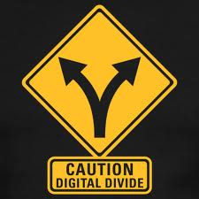**DIVIDE.**

The idea that some information and communication technologies are vital to a quality civic life is not new. It’s hard to imagine a life without computers, but even for a country as wired as the U.S, there is still a wide gap between those who have access technology and the skills to benefit from it.

Some government initiatives have been set up to reduce the gap in the information for example